Building Virtual Environment: Final Project

Topic: Solar System Simulator

**Description:**

This is a Solar System Simulator build with WebVR functionality enabled by AFrame.js.

Solar system is built by creating orbits and considering planetary radius along with orbital radius.Planets and Sun are created using <a-entity> and planetary properties are assigned to each planet in it. By Using DOM manipulation these properties are accessed and planetary position has been decided.

Planets are set into orbital motion using <a-animation>.To see solar system three cameras are defined using <a-camera> which are positioned to give Top view, side view and angular view of the solar system. Cameras can be selected using keyboard controls which are embedded using Keypress.js.

Cursor control is enabled using event handlers for this environment which when placed on any planet, gives the information about that planet.

Planets are assigned with specific texture and mixins.

**Technology Stack:** AFrame.js, jQuery, Keypress.js

**Screenshots:**

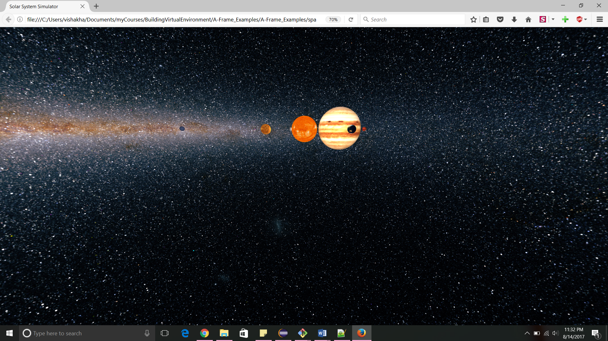

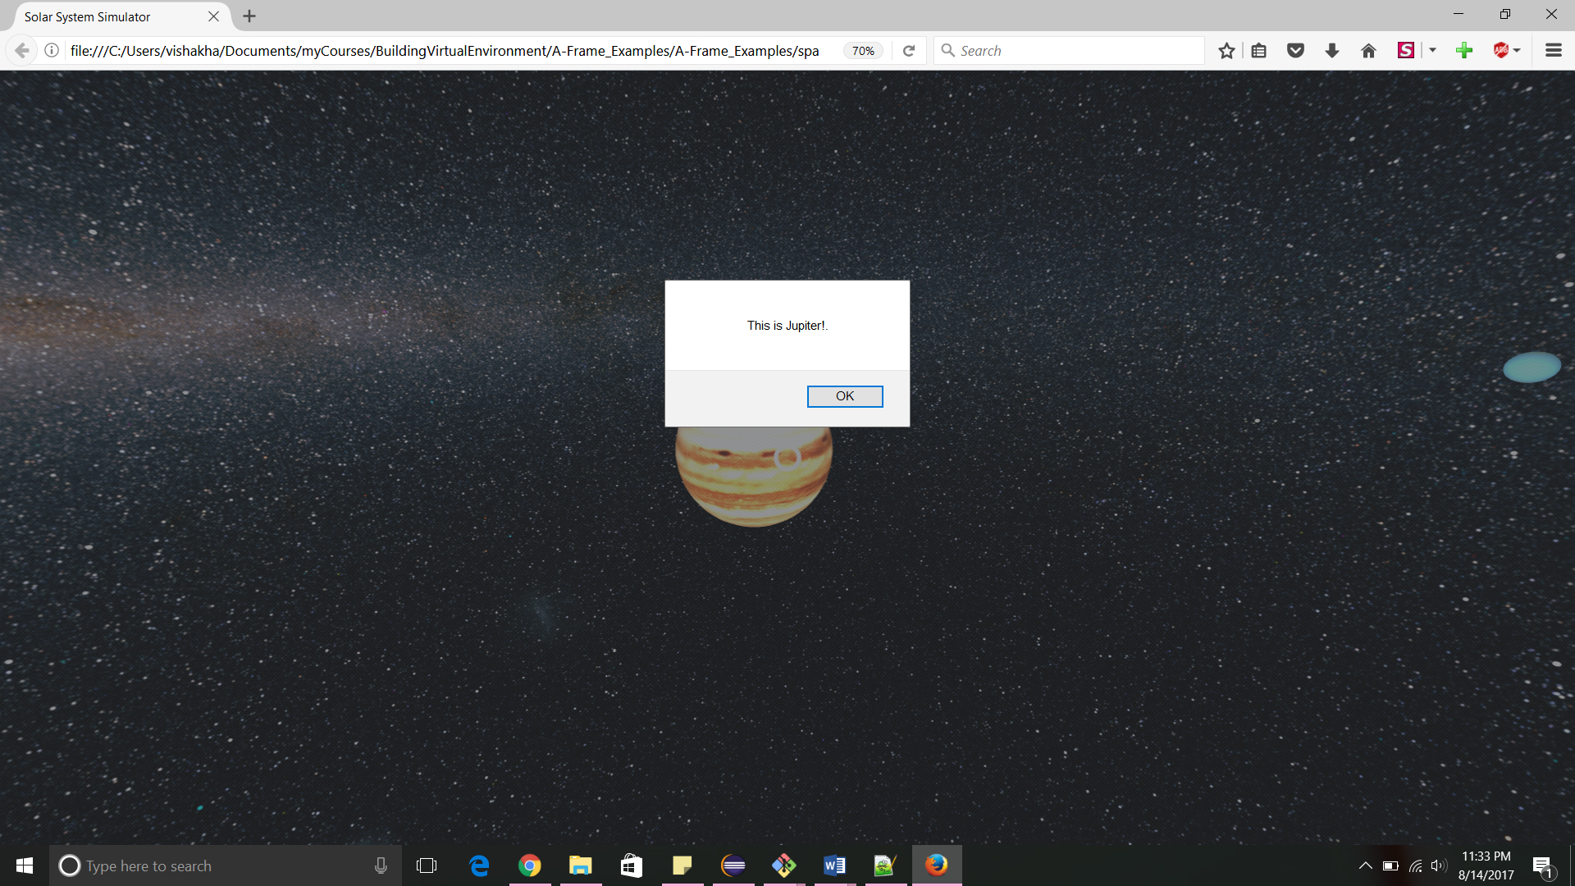

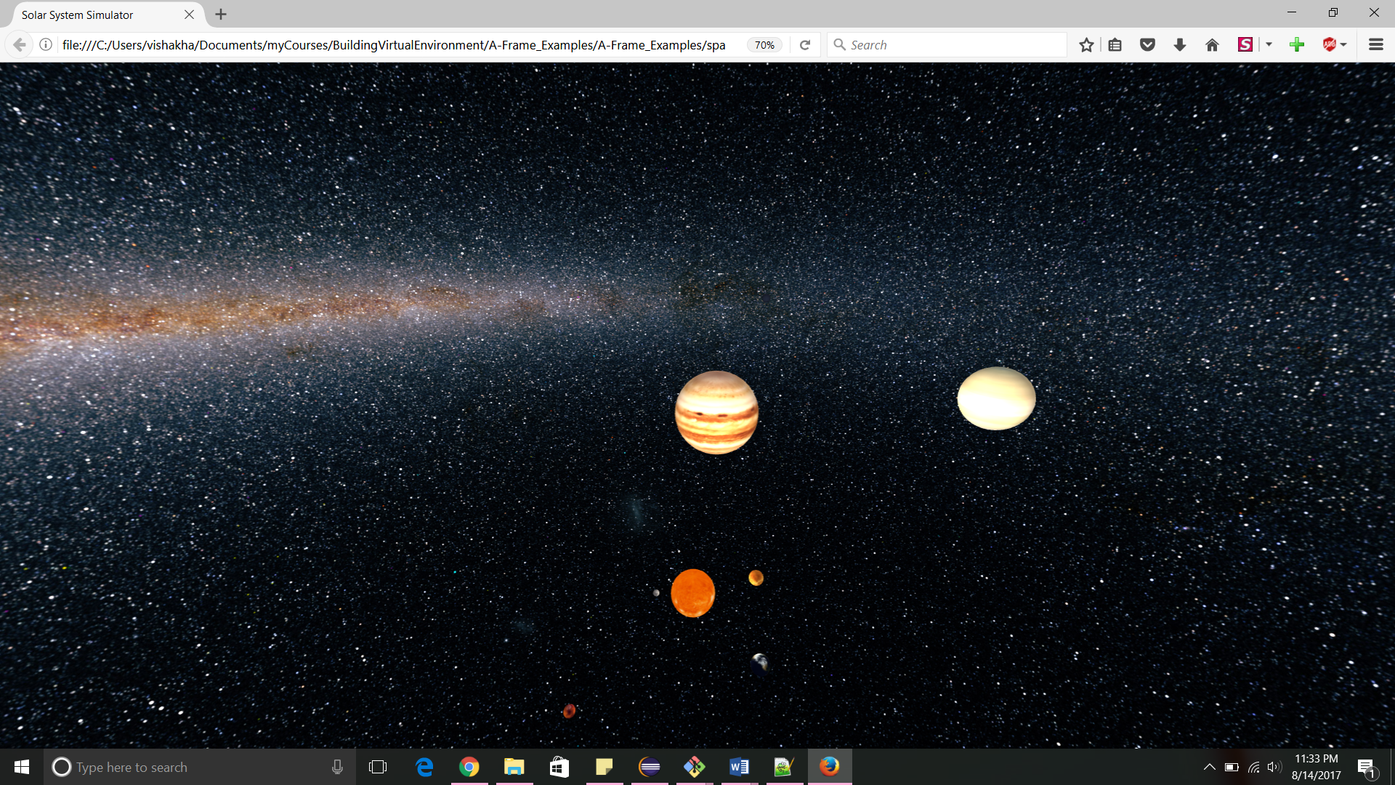

**Code:**

**1.spacevr.html**

<!doctype html>

<html>

<head>

<title>Solar System Simulator</title>

<meta name="viewport" content="width=device-width,initial-scale=1,shrink-to-fit=no,user-scalable=yes,maximum-scale=1">

<meta name="apple-mobile-web-app-capable" content="yes">

<script src="https://aframe.io/releases/0.6.1/aframe.min.js"></script>

<script src="js/global-functions.js"></script>

<script src="js/keypress.js"></script>

<!--style>

*{

cursor: none;

}

</style-->

</head>

<body>

<a-scene id="main-scene" fog="type: exponential; color: #000; density: .0003">

<a-assets>

<a-mixin id="planet" material="roughness: 1; metalness: 0"></a-mixin>

<img id="milkyimg" src="assets/milky-equi.jpg">

<audio id="song" src="assets/song.mp3" preload="auto"></audio>

</a-assets>

<!-- Global Settings -->

<a-sky src="#milkyimg" material="fog: false"></a-sky>

<a-light color="#fff" type="ambient" intensity="1"></a-light>

<!-- Global Camera -->

<a-camera id="camera" position="5 3 5" active="true" wasd-controls>

</a-camera>

<a-camera id="camera-angular" position="0 500 500" active="true" wasd-controls>

<!--a-entity cursor="fuse: true; fuseTimeout: 500"

position="0 0 -1"

geometry="primitive: ring; radiusInner: 0.02; radiusOuter: 0.03"

material="color: white; shader: flat">

</a-entity-->

</a-camera>

<a-camera id="camera-top" position="0 300 0" active="false" wasd-controls>

<a-entity cursor="fuse: true; fuseTimeout: 500"

position="0 0 -1"

geometry="primitive: ring; radiusInner: 0.02; radiusOuter: 0.03"

material="color: white; shader: flat">

</a-entity>

</a-camera>

<a-camera id="camera-side" position="0 0 500" active="false" wasd-controls>

<!--a-entity cursor="fuse: true; fuseTimeout: 500"

position="0 0 -1"

geometry="primitive: ring; radiusInner: 0.02; radiusOuter: 0.03"

material="color: white; shader: flat">

</a-entity-->

</a-camera>

<!-- World Elements -->

<a-entity id="universe" sound="src:#song autoplay: true">

<a-sphere id="sun"

class="star"

radius="695700" material="src: url(assets/sun.jpg)" >

<a-light color="#F7F3D2" type="point" decay=".1" intensity="1"></a-light>

</a-sphere>

<!--

km planetary-radius

planetary-color

planetary-axis

deg planetary-position

km orbital-radius

km/s orbital-speed

-->

<a-entity id="mercury"

class="planet"

planetary-radius="2439.7"

planetary-axis="0 0 0"

planetary-position="0"

orbital-radius="57909050"

orbital-speed="47.362"

cursor-listener>

<a-sphere mixin="planet" material="src: url(assets/mercury.jpg)"></a-sphere>

<a-animation></a-animation>

<a-text value="This is Mercury!." align="center" color="#FFF"></a-text>

</a-entity>

<a-entity id="venus"

class="planet"

planetary-radius="6051.8"

planetary-axis="0 0 0"

planetary-position="0"

orbital-radius="108208000"

orbital-speed="35.02"

cursor-listener>

<a-sphere mixin="planet" material="src: url(assets/venus.jpg)"></a-sphere>

<a-animation></a-animation>

<a-text value="This is Venus!." align="center" color="#FFF"></a-text>

</a-entity>

<a-entity id="earth"

class="planet"

planetary-radius="6371.0"

planetary-axis="0 0 0"

planetary-position="0"

orbital-radius="149598023"

orbital-speed="29.78"

cursor-listener>

<a-sphere mixin="planet" material="src: url(assets/earth-equi.jpg)"></a-sphere>

<a-animation></a-animation>

<a-text value="This is Earth!." align="center" color="#FFF"></a-text>

<!-- <a-camera id="camera-planet-earth" position="0 2 2" active="true"></a-camera> -->

</a-entity>

<a-entity id="mars"

class="planet"

planetary-radius="3389.5"

planetary-axis="0 0 0"

planetary-position="0"

orbital-radius="227939200"

orbital-speed="24.077"

cursor-listener>

<a-sphere mixin="planet" material="src: url(assets/mars.jpg)"></a-sphere>

<a-animation></a-animation>

<a-text value="This is Mars!." align="center" color="#FFF"></a-text>

</a-entity>

<a-entity id="jupiter"

class="planet"

planetary-radius="69911"

planetary-axis="0 0 0"

planetary-position="0"

orbital-radius="778299000"

orbital-speed="13.07"

cursor-listener>

<a-sphere mixin="planet" material="src: url(assets/jupiter.jpg)"></a-sphere>

<a-animation></a-animation>

<a-text value="This is Jupiter!." align="center" color="#FFF"></a-text>

<!-- <a-camera id="camera-planet-jupiter" position="0 2 2" active="false"></a-camera> -->

</a-entity>

<a-entity id="saturn"

class="planet"

planetary-radius="58232"

planetary-axis="0 0 0"

planetary-position="0"

orbital-radius="1429390000"

orbital-speed="9.69"

cursor-listener>

<a-sphere mixin="planet" material="src: url(assets/saturn.jpg)"></a-sphere>

<a-animation></a-animation>

<a-text value="This is Saturn!." align="center" color="#FFF"></a-text>

</a-entity>

<a-entity id="uranus"

class="planet"

planetary-radius="25362"

planetary-axis="0 0 0"

planetary-position="0"

orbital-radius="2875040000"

orbital-speed="6.80"

cursor-listener>

<a-sphere mixin="planet" material="src: url(assets/uranus.jpg)"></a-sphere>

<a-animation></a-animation>

<a-text value="This is Uranus!." align="center" color="#FFF"></a-text>

</a-entity>

<a-entity id="neptune"

class="planet"

planetary-radius="24622"

planetary-axis="0 0 0"

planetary-position="0"

orbital-radius="4504450000"

orbital-speed="5.43"

cursor-listener>

<a-sphere mixin="planet" material="src: url(assets/neptune.jpg)"></a-sphere>

<a-animation></a-animation>

<a-text value="This is Neptune!." align="center" color="#FFF"></a-text>

</a-entity>

</a-entity>

</a-scene>

<script>

var settings = {

camera: 'camera',

scalarOrbitalRadius: 1 / 1000000,

// Scales the planetary radius

scalarPlanetaryRadius: 1 / 500,

// Scales the Sun's radius

scalarSunRadius: 1 / 20000,

// Auto-enter VR

enterVR: true,

// Auto-reload, uses reloadTime

reload: false,

// In seconds

reloadTime: 20

}

/*

Setup global variables

*/

var scene = document.querySelector('#main-scene');

var universe = document.querySelector('#universe');

var planets = {

els: scene.querySelectorAll('.planet'),

// The rest of the object gets built with buildPlanets()

}

var cameras = {

els: scene.querySelectorAll('a-camera'),

active: settings.camera

// The rest of the object gets built with buildCameras()

}

/*

Add event listener to run after scene is loaded

*/

scene.addEventListener('loaded', function(){

/*var entity = document.querySelector('[sound]');

entity.components.sound.playSound();*/

buildPlanets(planets);

scaleSun()

devTools();

});

/*

Keylistener functions

*/

// Setup

var keyListener = new window.keypress.Listener();

keyListener.simple_combo('l', function(){

toggleCameraTo('camera-top');

});

keyListener.simple_combo('o', function(){

toggleCameraTo('camera-angular');

});

keyListener.simple_combo('p', function(){

toggleCameraTo('camera-side');

});

AFRAME.registerComponent('cursor-listener', {

init: function () {

var el = this.el; // <a-entity>

el.addEventListener('mouseenter', function () {

el.setAttribute('color', '#24CAFF');

});

el.addEventListener('mouseleave', function () {

el.setAttribute('color', '#EF2D5E');

});

el.addEventListener('click', function () {

alert(el.querySelector('a-text').getAttribute('value'));

});

}

});

function buildPlanets(planets){

// Loop it to build {}

for(i = 0; i < planets.els.length; i++){

var planet = planets.els[i];

var planetName = planet.getAttribute('id');

var planetEl = scene.querySelector('#' + planetName)

// Create the planet object entry and scale appropriately

planets[planetName] = {

el: planetEl,

classes: planetEl.getAttribute('class'),

planetaryRadius: planetEl.getAttribute('planetary-radius') * settings.scalarPlanetaryRadius,

planetaryColor: planetEl.getAttribute('planetary-color'),

// planetaryAxis: planetEl.getAttribute('planetary-axis'),

planetaryPosition: planetEl.getAttribute('planetary-position'), // rotational angle to euclidian

orbitalRadius: planetEl.getAttribute('orbital-radius') * settings.scalarOrbitalRadius,

orbitalSpeed: planetEl.getAttribute('orbital-speed')

};

// Create the planet in the DOM

var planetDOM = planets[planetName].el.querySelector('a-sphere');

planetDOM.setAttribute('geometry', {

primitive: 'sphere',

radius: planets[planetName].planetaryRadius

});

planetDOM.setAttribute('position', { //TODO correct math

x: Number(planets[planetName].orbitalRadius) * Math.sin(Number(planets[planetName].planetaryPosition) * Math.PI),

y: 0,

z: Number(planets[planetName].orbitalRadius) * Math.cos(Number(planets[planetName].planetaryPosition) * Math.PI)

});

var info=planets[planetName].el.querySelector('a-text');;

info.setAttribute('position', { //TODO correct math

x: Number(planets[planetName].orbitalRadius) * Math.sin(Number(planets[planetName].planetaryPosition) * Math.PI)+20,

y: 0,

z: Number(planets[planetName].orbitalRadius) * Math.cos(Number(planets[planetName].planetaryPosition) * Math.PI)

});

//info.setAttribute("visible",false);

// Create the animation in the DOM

var animationDOM = planets[planetName].el.querySelector('a-animation');

animationDOM.setAttribute('attribute', 'rotation');

animationDOM.setAttribute('dur', 360 / planets[planetName].orbitalSpeed * 1000);

animationDOM.setAttribute('fill', 'forwards');

animationDOM.setAttribute('to', '0 360 0');

animationDOM.setAttribute('repeat', 'indefinite');

animationDOM.setAttribute('easing', 'linear')

}

// Return the object

return planets;

}

function scaleSun(){

var sunEl = scene.querySelector('#sun')

var sunRadius = sunEl.getAttribute('radius');

sunEl.setAttribute('radius', sunRadius * settings.scalarSunRadius);

}

function devTools(){

if(settings.enterVR == true){

scene.enterVR();

}

// If the reload setting is turned on, enterVR and reload the page after a set time

if(settings.reload == true){

reloadPage(settings.reloadTime);

}

}

</script>

</body>

</html>

**2. global-functions.js**

/*

Keylistener functions

*/

// Setup

//var keyListener = new window.keypress.Listener();

// check targets object

// keyListener.simple_combo('letter', function(){

// do a thing

// });

/*

Reload page after so many seconds, used for development

*/

function reloadPage(seconds){

function reloadCallback(){

return function(){

window.location.reload();

}

}

var millis = seconds * 1000;

setTimeout(reloadCallback(), millis);

}

/*

Toggle to a target. Works by setting all targets below the ground plane, then pulling up the active one

*/

function devTools(){

if(settings.enterVR == true){

scene.enterVR();

}

// If the reload setting is turned on, enterVR and reload the page after a set time

if(settings.reload == true){

reloadPage(settings.reloadTime);

}

}

function toggleCameraTo(targetCamera){

if(cameras.active != undefined){

activeCamera = cameras.active;

}else if(settings.camera != undefined){

activeCamera = settings.camera;

}else{

return;

}

// Deactivate active camera

scene.querySelector('#' + activeCamera).setAttribute('active', false);

// Activate target camera

scene.querySelector('#' + targetCamera).setAttribute('active', true);

// Set new active camera

cameras.active = targetCamera;

}

**Project Files Location:**

<https://github.com/sawantv02/BuildingVirtualEnvironment/tree/master/Final_SolarSystem>